

Automatic Storage and Retrieval System
Set-up and running
Procedure when connected to a Denford CIM System

April 2005

Running the ASRS with 2005 Software

The 3 ASRS tabs are:-

HOME: - Homing all 3 axes
SETUP /JOG (Toggles): - Setting positions, Pick and Place routines and jogging axes
AUTO: - Connects to the CIM system
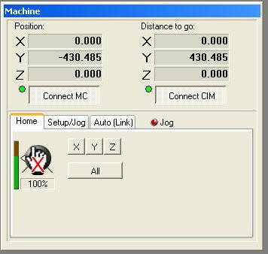
Running the ASRS

- Turn ON the mains supply isolator on the ASRS Control box

- Ensure the Emergency Stop button is not activated

- Turn the "Speed Override" dial fully Anticlockwise (i.e. 0% speed)

- Run the ASRS.EXE

- Select the CONNECT MC button (Down load MINT file to ASRS)

- Select the CONNECT CIM button (Links ASRS to CIM Software)

- Mouse click the SET UP tab to get into JOG mode.

- Select the SETUP/JOG tab and jog all the axes to safe positions (Note the JOG LED will go GREEN i.e. Active)

Jog each axis into a "Safe Position" ready for "Homing" (Towards the Right Hand Side of the ASRS)
Note?

“X” Axis ← Left / Right → buttons

“Y” Axis ↑ Up / Down ↓ buttons
“Z” Axis Page Up / Page Down buttons

Load the pallets with their respective chess billets and ensure that the correct billet is in the correct pallet, wrongly loading a pallet with the wrong billet could cause damage to the Machine Tools.
*** KING Billet length 31.75mm dia x 80.5mm ***
*** QUEEN Billet length 31.75mm dia x 70.5mm ***
*** RANK (This includes BISHOP, KNIGHT & ROOK)
Billet length 31.75mm dia x 60.5mm ***
*** PAWN Billet length 31.75mm dia x 45.5mm ***
*** KING Billet material: - ISO T3 2011 Aluminium Alloy
*** QUEEN Billet material: - ISO T3 2011 Aluminium Alloy
*** RANK Billet material: - ISO T3 2011 Aluminium Alloy
*** PAWN Billet material: - ISO T3 2011 Aluminium Alloy

- Check that all the pallets are correctly loaded into the ASRS on side 1 (Note? side 1 is the one opposite the ASRS Control box side i.e. side 2).

- Note? The INVENT.DAT (On the Host / Cell PC) file (Standard default name but you can create your own .DAT file) should represent the positions of the pallets on side 1 of the ASRS. (Note? The .DAT file should be viewed as looking on side 1 of the ASRS from the Control box side on the ASRS i.e. side 2.)

- Select the HOME tab

- Select the ALL button (Or individual X,Y,Z buttons)

- Once all the axes have homed select the AUTO(LINK) tab when ready to run in CIM mode

Typical commands ( Note? _ is a SPACE)

A) PICK ASRS 1_2_3 PLACE CONV PICK CONV

The numbers 123 represent Side 1, Row 2, Column 3 (5 X 5)

B) PICK ASRS 1_1_1

The numbers 111 represent Side 1, Row 1, Column 2 (5 X 5)

C) PLACE ASRS 2_3_4

The numbers 234 represent Side 2, Row 3, Column 4 (5 X 5)

D) PICK CONV PLACE AGV PICK AGV

Setting positions and sequences

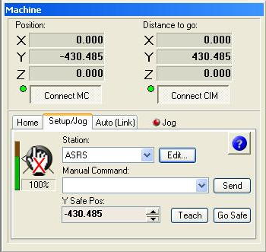

ASRS Location
Side 1 Row 1 Column 1

ASRS Size Sides 2
Rows 5
Columns 5

XYZ Position

These are the XYZ positions for the ASRS location above (By setting Side 1 Row 1 Column 1 you can use the LOCATION STEP distance to teach all the other pallet stations in the ASRS.

The pitch between rows and columns needs measuring (Note the +/- signs) Direction toward the datum switch is + (Positive)

e.g. X=266 Y=-194

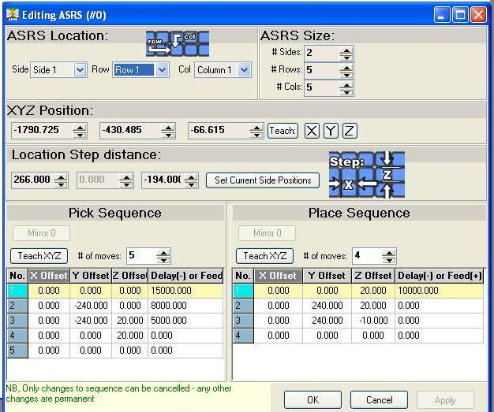

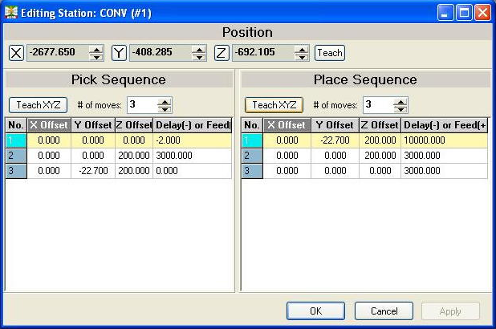
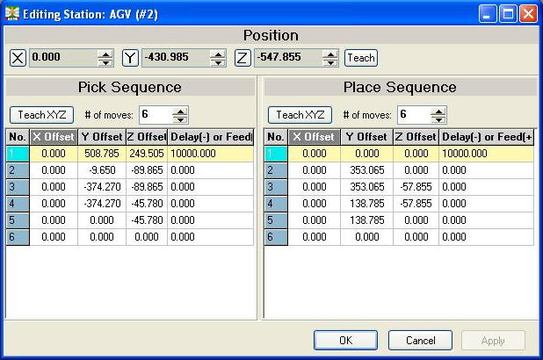

Note?

In SETUP (From the main menu bar) then PARAMETERS, there is an option to go to a safe “Y” position after every sequence has been completed. This is OK to use if the Centre Line of the ASRS is in line with the Centre Line of the gap in the Conveyor where the pallet arm loads / unloads the pallets. If it is not then it should be left unticked. This is because in a PLACE CONV PICK CONV sequence, after the PLACE CONV has been carried out it will try and move to the safe “Y” position and will hit the conveyor.

The option is in the ASRS.INI file under [OPTIONS]

Useysafepos = 1 (SET)
Useysafepos = 0 (NOT SET)

